LOGIQUIDS PRACTICE TEST
Assessment 2 • Junior KG • 25 Questions
Name: ____________________ | Date: ______________ | Score: ______ / 25
How to answer: Look carefully at each question and draw a circle around the letter (A, B, C or D) of the correct answer. Parent can read the question aloud. Suggested time: 60 minutes.
Q1. What will come in place of "?" in the given series?
3-1-3, 3-2-3, 3-3-3, 3-4-3, ?
A 3-5-5 | B 3-5-3 | C 5-3-5 | D 3-6-3

Q2. What will come in place of "?" in the given series?
A, c, E, g, I, ?
A K | B j | C k | D L

Q3. What will come in place of "?" in the given series?
11, 22, 33, 44, ?
A 55 | B 45 | C 54 | D 66

Q4. What will come in place of "?"
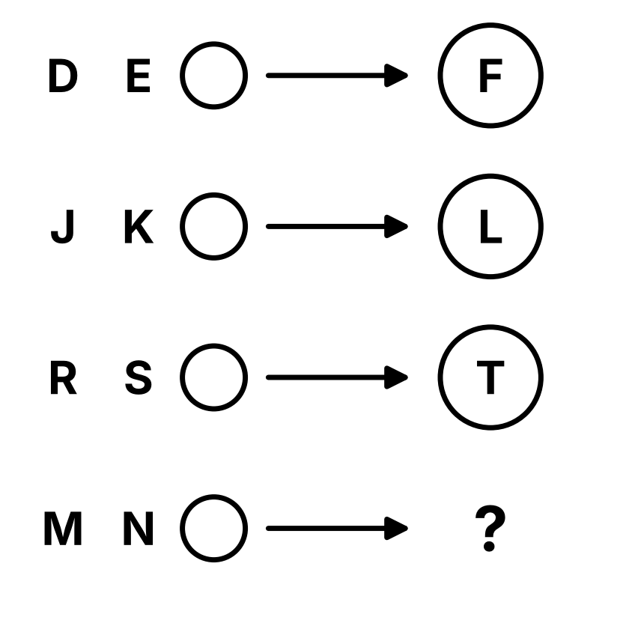
  A L | B O
  C P | D N

Q5. What will come in place of "?"
BALL → BA
CAKE → CA
DOLL → DO
RAIN → ?
A AR | B RI | C RA | D IN

Q6. What will come in place of "?"
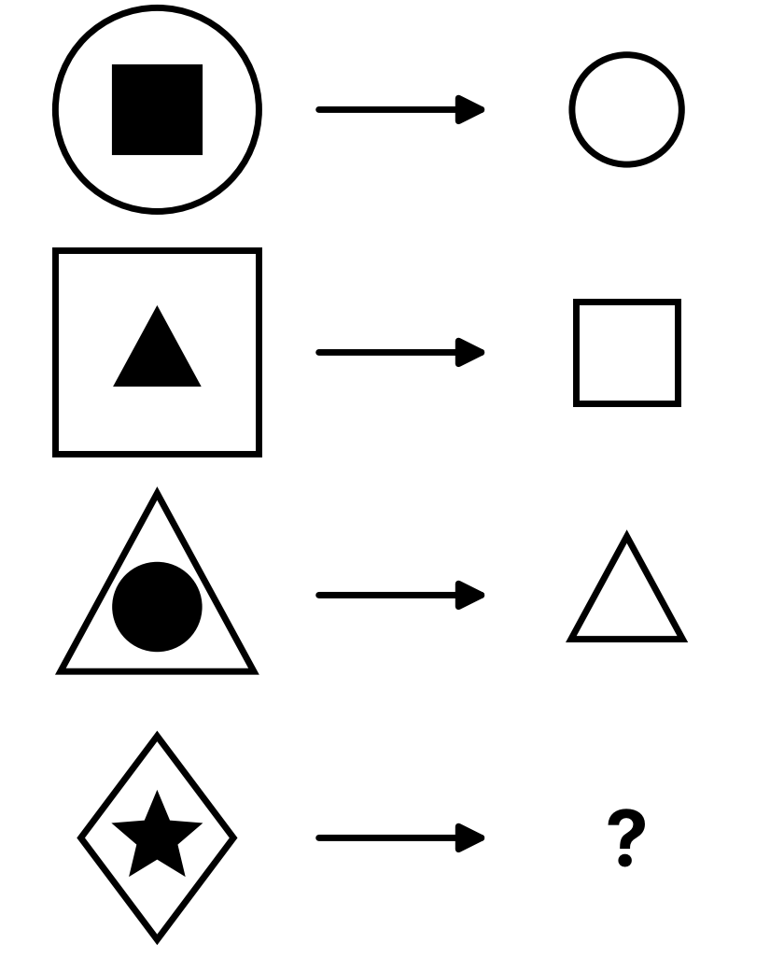
  A   | B  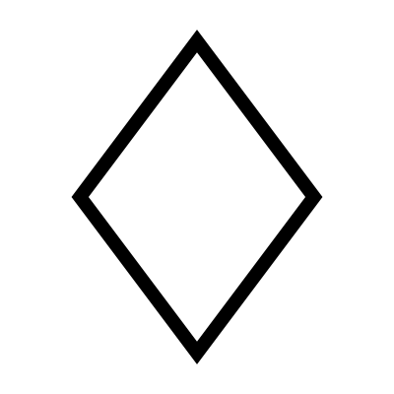
  C   | D  

Q7. What will come in place of the "?"
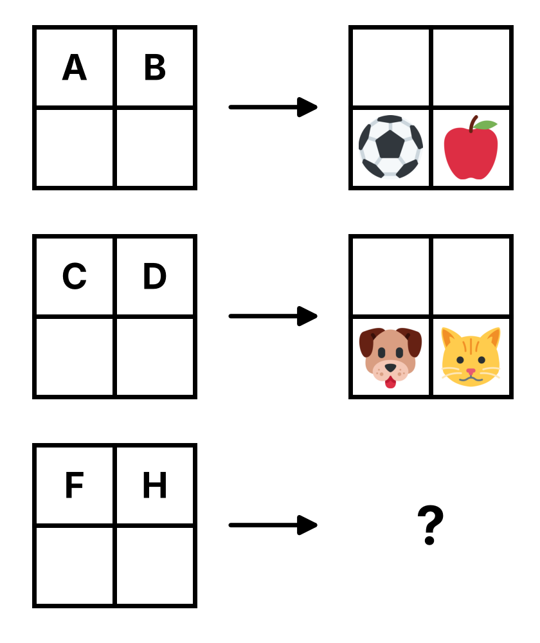
  A  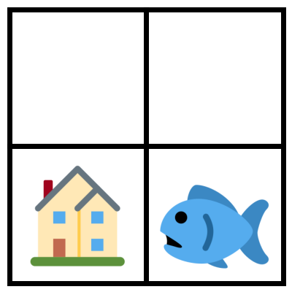 | B  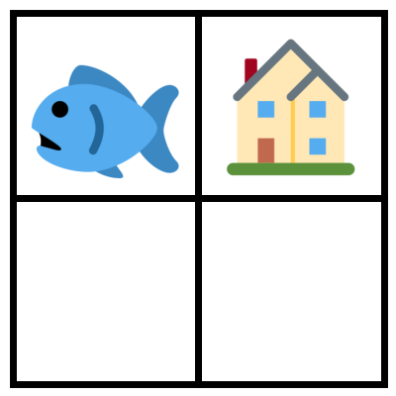
  C  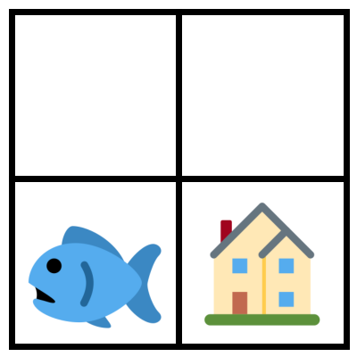 | D  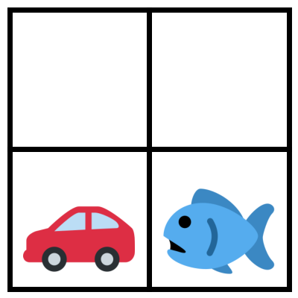

Q8. What will come in place of the "?"
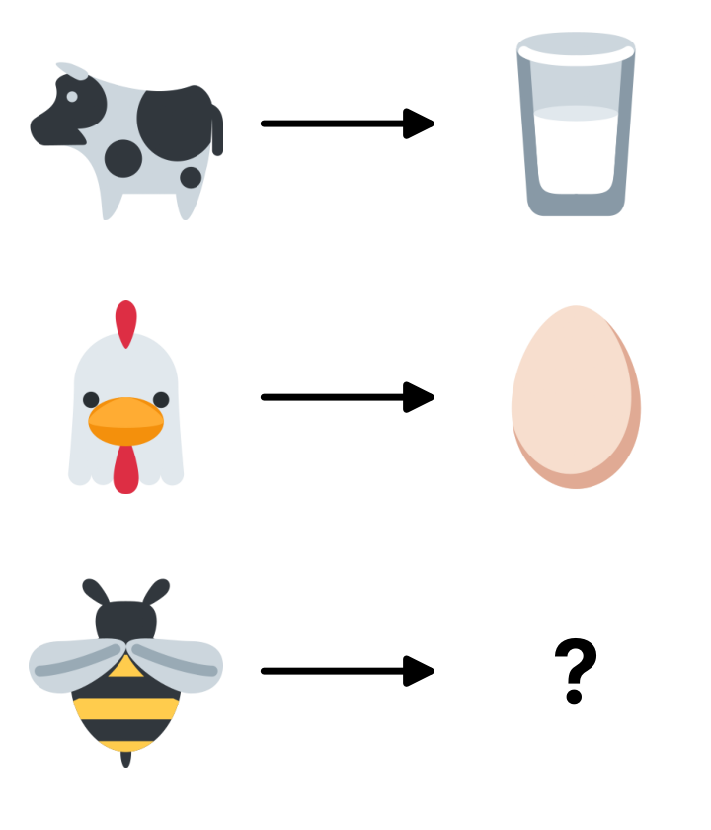
  A   | B  
  C   | D  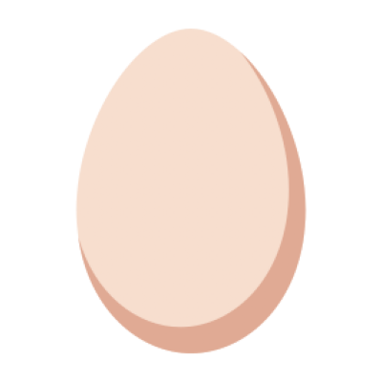

Q9. Find the odd one out.
Note: It is not related to the number of letters, vowels or consonants of the words.
A 4 Four | B 7 Seven | C 9 Six | D 3 Three

Q10. Find the odd one out.
A  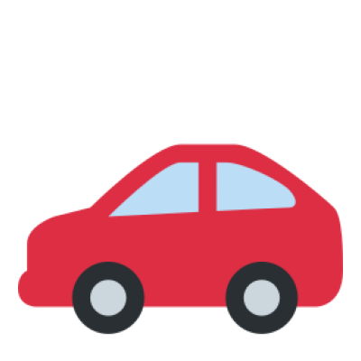 | B   | C   | D  

Q11. Find the odd one out.
Note: You may turn the shapes around in your mind.
A  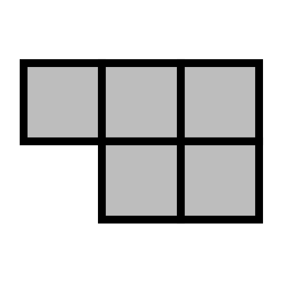 | B  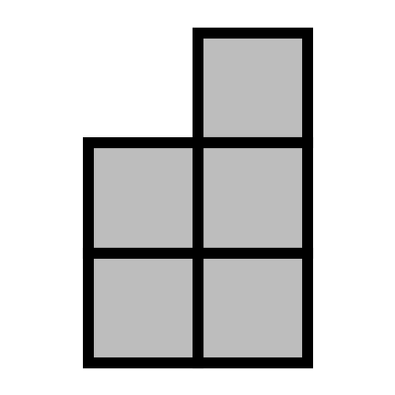 | C  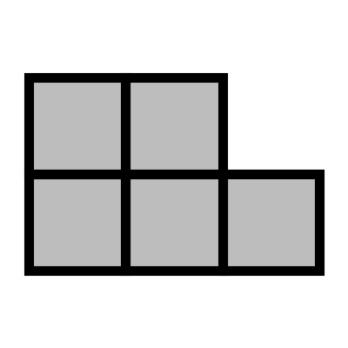 | D  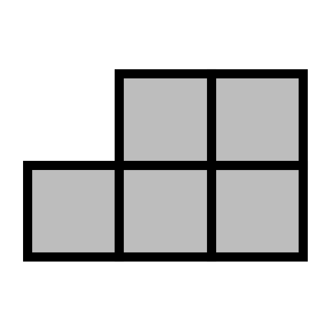

Q12. Which option is NOT a part of the question image?
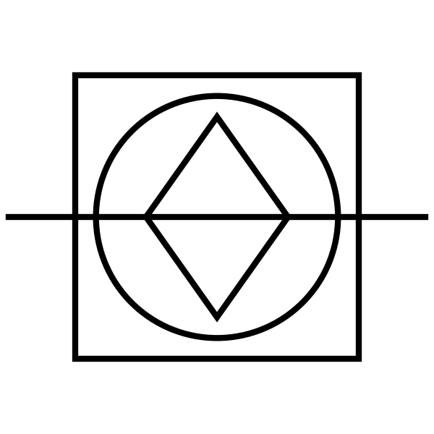
  A | B
  C | D  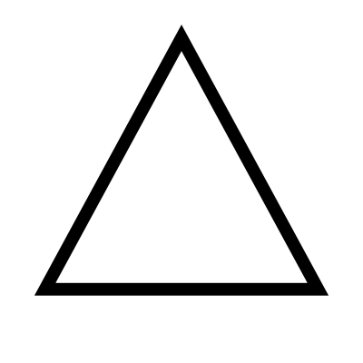

Q13. Which of the following objects is NOT present in the question image?
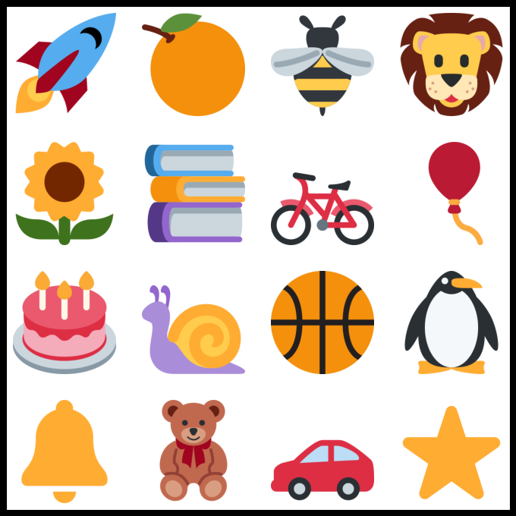
  A  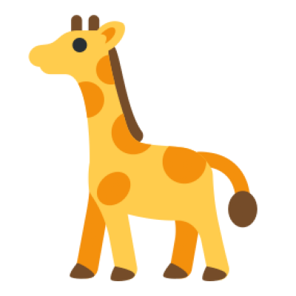 | B  
  C   | D  

Q14. Find the missing part of the image.
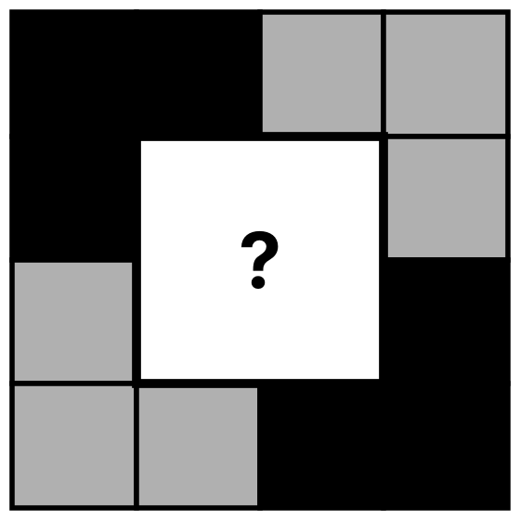
  A  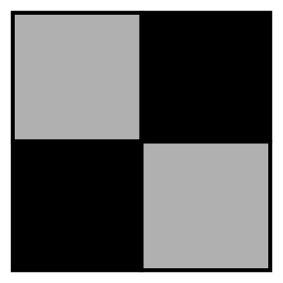 | B  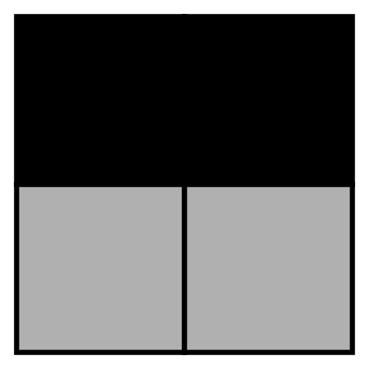
  C  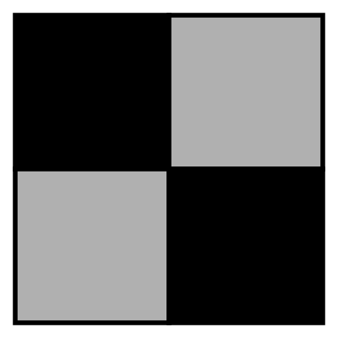 | D  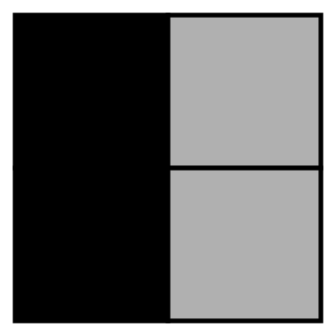

Q15. Which of the following options has the letter "T" present in it?
Note: Images in the options cannot be rotated.
A  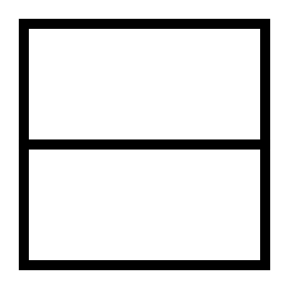 | B  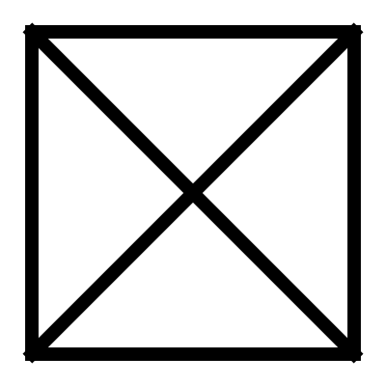 | C  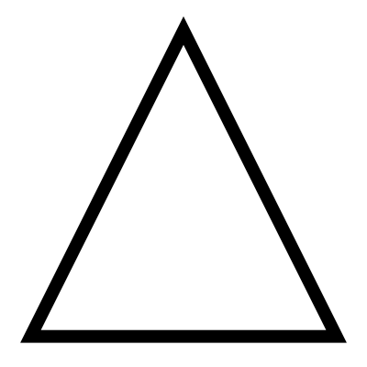 | D  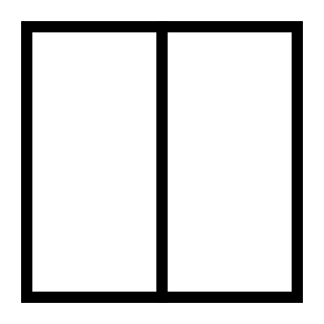

Q16. Find the missing half which is most similar to the image given below.
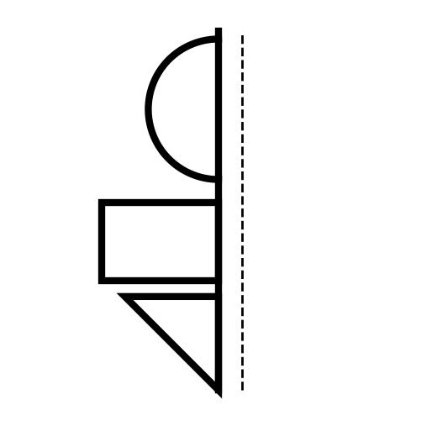
  A  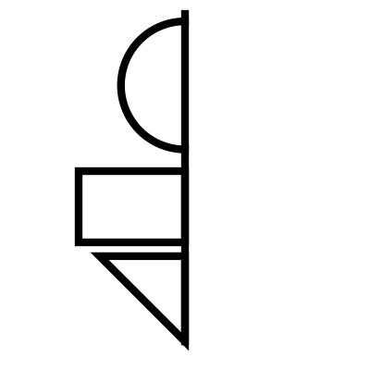 | B  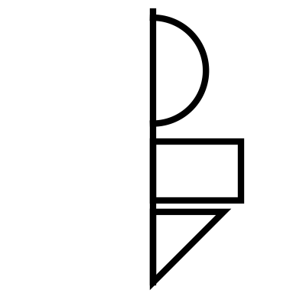
  C  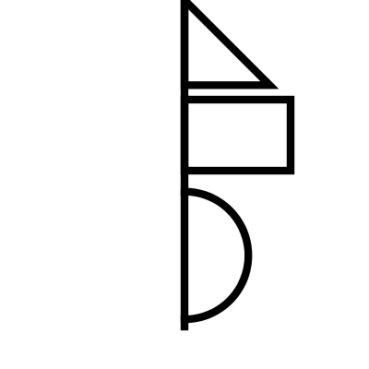 | D  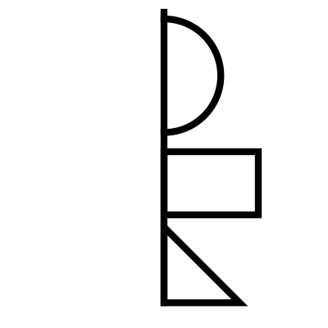

Q17. Count the number of circles in the image given below.
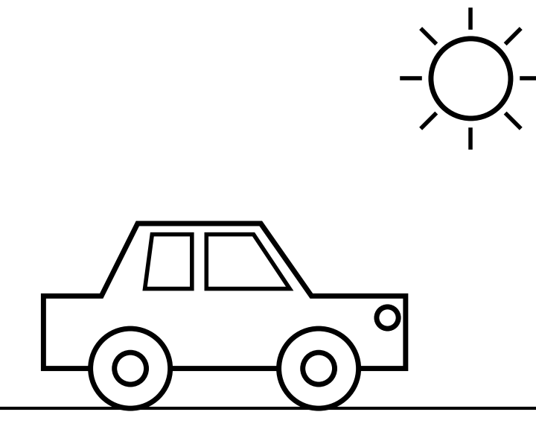
  A 6 | B 7
  C 8 | D 5

Q18. Count the number of rectangles in the given figure.
Note: Please count all the squares as rectangles for this question.
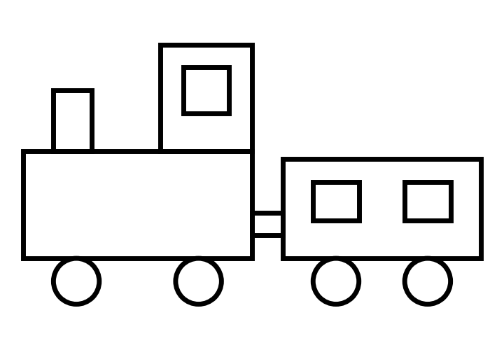
  A 6 | B 7
  C 8 | D 9

Q19. Count the number of small boxes with ONLY 2 WHITE stars in it.
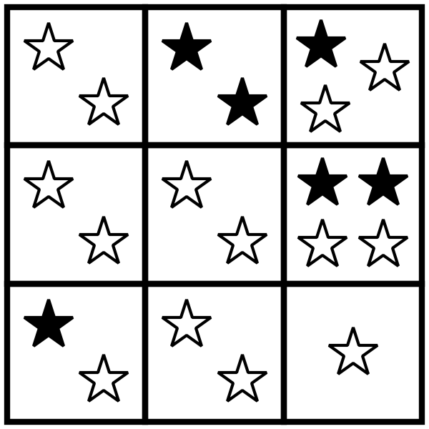
  A 3 | B 4
  C 5 | D 6

Q20. Which of the following options could be the shadow of the car given in the question image?
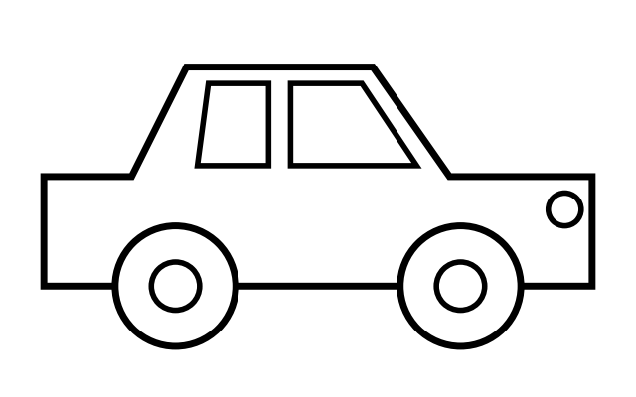
  A   | B  
  C   | D  

Q21. What will come in place of "?" ★ LQ Champ
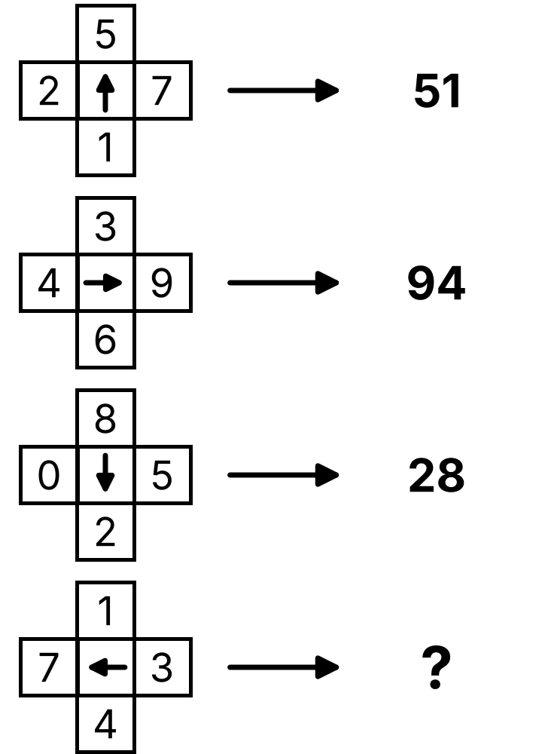
  A 37 | B 73
  C 14 | D 41

Q22. Count the number of triangles in the image given below. ★ LQ Champ
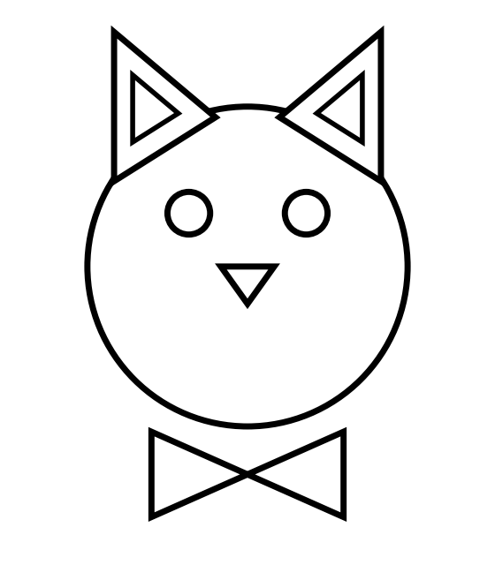
  A 5 | B 6
  C 7 | D 8

Q23. What will come in place of "?" in the given series? ★ LQ Champ
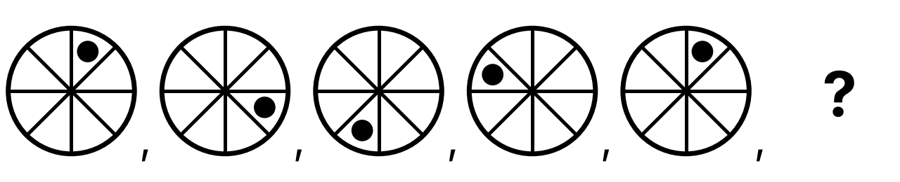
A  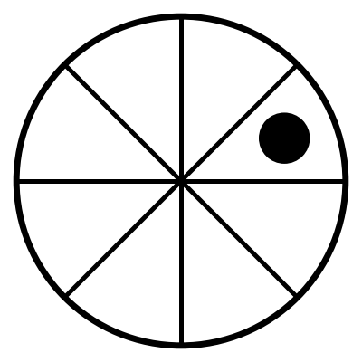 | B  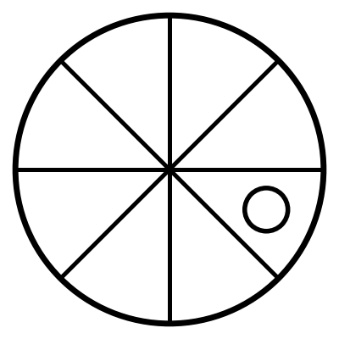 | C  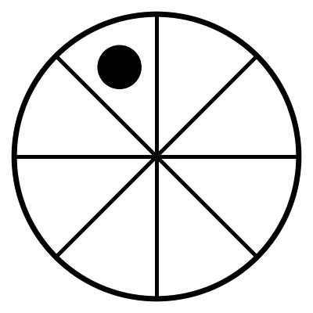 | D  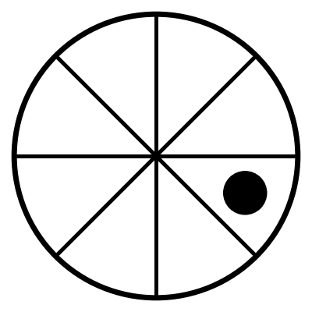

Q24. Which animal is NOT HIDDEN behind the wall? ★ LQ Champ
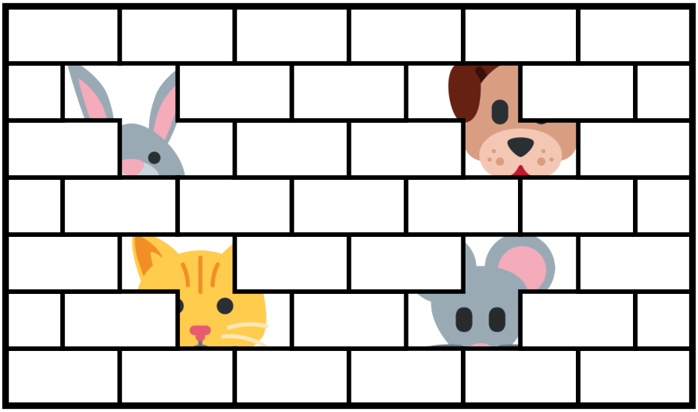
  A Rabbit | B Dog
  C Lion | D Cat

Q25. Which option is NOT present in the given image? ★ LQ Champ
Note: Rotation of an option image or part of it is not allowed.
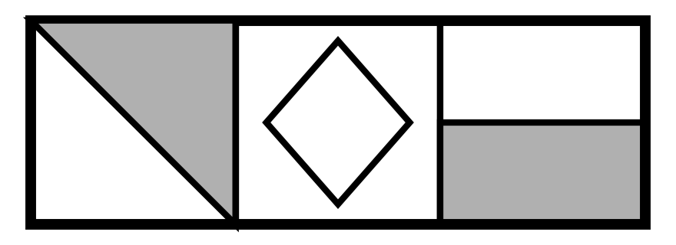
A  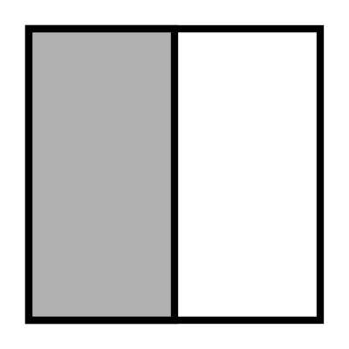 | B  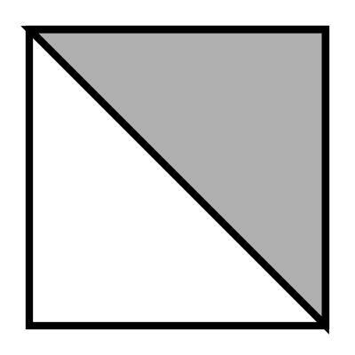 | C  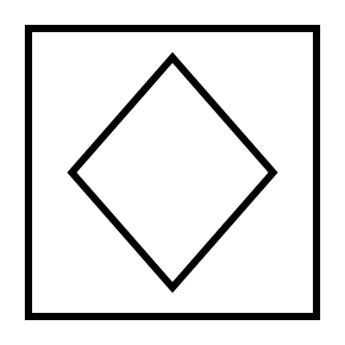 | D  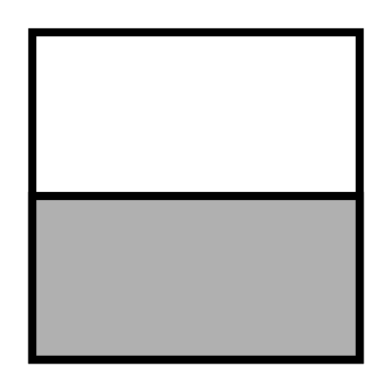

Answer Key — Assessment 2 (for parents)
Q | Answer | Why
1 | B | Middle number goes up by 1, ends stay 3
2 | C | Skip one letter each time, capital and small take turns (A, c, E, g, I, k)
3 | A | Both digits are the same and go up by 1
4 | B | The letter that comes next after the two letters
5 | C | First two letters of the word
6 | B | Answer is the big outer shape
7 | A | Top-left letter → its picture bottom-right; top-right letter → its picture bottom-left (Fish, House)
8 | B | What each animal gives us: bee gives honey
9 | C | Number matches the word in all others; 9 is not Six
10 | D | Aeroplane flies, the others go on the road
11 | D | D is a flipped (mirror) shape, others are turned
12 | D | There is no triangle in the picture
13 | A | There is no giraffe in the picture
14 | C | Black and grey blocks continue the 2×2 pattern
15 | D | Top line with a line going down from its middle makes T
16 | B | Mirror image of the half
17 | A | 2 wheels, 2 wheel centres, 1 headlight, 1 sun
18 | C | Engine, cabin, cabin window, chimney, joiner, wagon, 2 wagon windows
19 | B | Top-left, middle-left, centre and bottom-middle boxes
20 | A | Two wheels and the sloping roof match
21 | B | Number at arrow head comes first, then tail: 7 then 3
22 | C | 2 ears, 2 inner ears, 1 nose, 2 bow-tie triangles
23 | D | Black dot jumps two steps clockwise each time
24 | C | Rabbit, Dog, Cat and Mouse are hidden
25 | A | Grey on the left half is not there

